COGNITIVE WELLNESS (ELDERLY):

PARTNERSHIP
OPPORTUNITIES
Puzzle Crystal
Inclusive Cognitive Toy

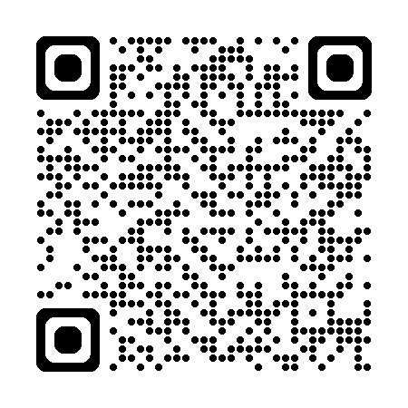

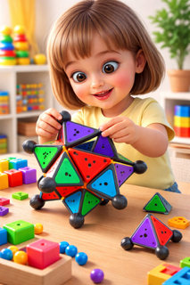

- Montessori-inspired
- STEM learning
- Family play
Contact: Igor Goldman
Email: Igor_Goldman1@yahoo.com
Phone: (301) 213-4467
Website: Solnishko.info
- Manufacturing
- Regional distribution
- Licensing opportunities
Product Advantages:
- Modular scalable design
- Universal packaging concept
- Suitable for multiple market segments
- Hand-eye coordination
- Focus and memory stimulation
- Gentle tactile brain exercise

For children (STEM/Montessori):
- Fine motor skills development
- Spatial thinking and symmetry
- Logical reasoning and problem solving
- Independent learning through hands-on play
For Family Play:
- Cooperative building activities
- Parent-child interaction
- Shared discovery and creativity
Cognitive Wellness (Elderly)
Inclusive Design (Low vision
support).

- Tactile surfaces and raised shapes
- High-contrast colors
- Braille-ready packaging options

INCLUSIVE DESIGN
(Low vision support):

OUR STORY
Born from Love.
Designed for Learning.
“Solnishko” brand was invented by a father and named after the birth of his daughter.
What started as a family puzzle became a patented cognitive toy designed to support learning, development, and meaningful connection across all ages.
- Family-founded invention
- Original geometric concept
- Protected intellectual property
US Patented Geometric Puzzle System,
Patent No.: US 8,511,685 B2

PRODUCTS AND APPLICATIONS
One Toy - Multiple Benefits

